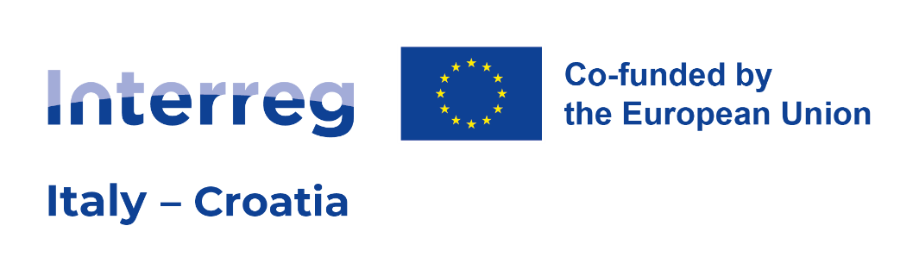

INTERREG ITALY-CROATIA PROGRAMME 2021 – 2027

DNSH PROCEDURE
GUIDELINES for OSI Applicants

2nd Call for Proposal
(Version n. 1 of 17 of September 2024)

TABLE OF CONTENTS

Sommario
1. INTRODUCTION 3
2. CAUSE OF EXCLUSION 4
3. PROTOCOL 5
⮚ Declaration: 6
⮚ Table of inclusion/non-inclusion 6
HOW TO FILL THE TABLE OF INCLUSION/NON-INCLUSION 6
⮚ Self-assessment tool: 7
Meaning of “NO” in the self-assessment tool 7
Meaning of “YES” in the self-assessment tool 7
⮚ Substantive Assessment 8
Figure 1: Self-Assessment Procedure 8
4. ANNEX 1 - LP/PP Declaration on DNSH 9
5. ANNEX 2 - Tables of inclusion/non-inclusion 10
6. ANNEX 3 – SELF-ASSESSMENT TOOL 18

INTRODUCTION

The purpose of the document is to provide OSI applicants a procedure (simplified self-assessment) for the performance of activities in projects with investment components, ensuring their compliance with the ‘do no significant harm’ principle (DNSH).

According to the Common Provisions Regulation (CPR), in the context of tackling climate change, the objectives of the Funds shall be pursued in line with the DNSH principle and in accordance with the EU Taxonomy Regulation (EU) 2020/852.

According to the Commission Explanatory Note “Application of the “Do No Significant Harm” Principle under Cohesion Policy”, for the purposes of the Interreg Italy-Croatia Programme, DNSH is to be interpreted within the meaning of Article 17 of the „Taxonomy Regulation “which defines what constitutes ‘significant harm’ for the six environmental objectives covered by the “Taxonomy Regulation”:

1. An activity is considered to do significant harm to climate change mitigation if it leads to significant greenhouse gas (GHG) emissions.
2. An activity is considered to do significant harm to climate change adaptation if it leads to an increased adverse impact of the current climate and the expected future climate, on the activity itself or on people, nature or assets.
3. An activity is considered to do significant harm to the sustainable use and protection of water and marine resources if it is detrimental to the good status or the good ecological potential of bodies of water, including surface water and groundwater, or to the good environmental status of marine waters.
4. An activity is considered to do significant harm to the circular economy, including waste prevention and recycling, if it leads to significant inefficiencies in the use of materials or in the direct or indirect use of natural resources, or if it significantly increases the generation, incineration or disposal of waste, or if the long-term disposal of waste may cause significant and long-term environmental harm.
5. An activity is considered to do significant harm to pollution prevention and control if it leads to a significant increase in emissions of pollutants into air, water or land.
6. An activity is considered to do significant harm to the protection and restoration of biodiversity and ecosystems if it is significantly detrimental to the good condition and resilience of ecosystems, or detrimental to the conservation status of habitats and species, including those of Union interest.

Before submitting the Programme for adoption by the Commission, the analysis of compliance with DNSH principle has been carried out for each of the seven Programme Specific Objectives in the Strategic Environmental Assessment document (SEA). The conclusion of the analysis of compliance is that the Programme complies with the DNSH principle, as the actions do not generate significant negative environmental impact.

Anyhow, the Programme is also responsible for the implementation of DNSH principle throughout the programming period and specifically in project selection phase. Therefore, a detailed screening shall be carried out in order to prevent the inclusion of activities or types of actions in the projects that could do significant harm to the environment.
In doing so, only those project operations that comply with the Programme (as the Programme itself complies with DNSH principle) and with applicable EU and National law will be selected and funded.

The applicable criteria which are considered in this document should assure that the implementation of the proposed investment activities or the application of its results have not significant adverse environmental or climate impacts.

The investment concerned will also be monitored both during the phase of the investment implementation (for instance in the occasion of the relevant Project Reports or through “ad hoc” on site controls checking the respect of DNSH commitments declared) and during project closure phase following a proper procedure.

OSI applicants are invited to read carefully the present document and to perform the self-assessment procedure which follows, attaching all documents in JEMS as Application Form annexes.

CAUSE OF EXCLUSION

In the following cases, the compliance / self-assessment of the DNSH principle is NOT required:

- Whether an Environmental Impact Assessment (EIA) or screening for the specific project activity has been completed, in accordance with Directive 2011/92/EU, and the decision of the competent authority is issued.
- For sites/operations located in or near biodiversity-sensitive areas (including the Natura 2000 network of protected areas, UNESCO World Heritage sites and Key Biodiversity Areas, as well as other protected areas), an appropriate assessment, where applicable, has been conducted and the decision of the competent authority is issued
- For any activities not included in JEMS section “Investment” of the Application Form, unless during Condition Clearing the LP is asked to complete the “Investment” section for activities that the project did not originally include.

PROTOCOL

- For the projects having investments (infrastructures and/or equipment) in the OSI Application Form, the JS provides a “DNSH” compliance procedure – a simplified Self-assessment procedure designed to ensure the compliance of the measures with the principle of “not causing significant harm”.
The same procedure will be followed in case, as a result of the condition clearing, the investment(s) are present in the proposal but the related section has not been filled by applicant.

The procedure requires that the OSI applicant will provide the Programme with the following documents duly filled:
- Declaration signed by the concerned LP/PP (see Annex 1)
- Table of Inclusion/non-inclusion (see Annex 2)
and (only if applicable):
- Self-assessment tool (Annex 3)
- Substantive assessment made by an experienced subject external to the concerned LP/PP

Declaration:
Digitally or handwritten (in this latter case a valid Identity Cards document shall be attached) signed by the concerned LR of the LP/PP.

Table of inclusion/non-inclusion
The table is extracted from the document SEA Extract for beneficiaries (pp 8-35). following the applicable S.O. It is a table of inclusion/non-inclusion in which the LP/PP shall match whether the concerned investment activity:
  - can be included in one or more aggregated typology of actions (ticking “YES” and providing a comment motivating briefly the reason of inclusion).
  - cannot be included in neither of the aggregated typology of actions (if ticking “NO”, no comment is needed and the LP/PP should proceed with filling the Self-assessment tool (for instance because the description of the “line of intervention” doesn’t perfectly match with the investment or the description of the “line of intervention” is too generic).

HOW TO FILL THE TABLE OF INCLUSION/NON-INCLUSION

To correctly fill in the table please carefully read the mentioned SEA Extract for beneficiaries and consider the following:
- for each type of action (INVESTMENT), please consider each of the topic within the meaning of Article 17 of the “Taxonomy Regulation”
- answer “YES” in case the concerned investment activity considering the specific topic can be included in one or more aggregated typology of actions (line of interventions) and motivate briefly the reason of inclusion and, if applicable, the mitigation measure to be taken for every possible negative externality caused by the intervention. (max 1000 character on the concerned aggregated typology of actions)
- answer “NO” in case the concerned investment activity cannot be included in neither of the aggregated typology of actions (this can also happen in case the description of the “aggregated typology of actions (line of intervention)” doesn’t perfectly match with the investment or the description of the “aggregated typology of actions (line of intervention)” is too generic). No comment/motivation provided in the table of inclusion/non-inclusion.

In case the concerned investment can be included in the table of inclusion/non-inclusion (i.e. “YES” is ticked and justification provided in the relevant box of the table) no need to fill the Self-assessment tool: it means that the investment is of a typology of action for which a positive DNSH assessment has been already carried out in the “Strategic Environmental Assessment document (SEA)”; in other word the typology of investment is compliant with DNSH regulation.

Self-assessment tool:
In case the concerned investment cannot be included in ANNEX 2, the Self-assessment tool must be filled in.
In this document you will have to assess whether or not your investment, based on the evaluation criteria, may or may not cause significant harm to the environment, considering the specific topic.
In the Self-assessment tool, a Yes/No answer should be provided as regards the evaluation criteria. Short description clarifying the impact following the concerned topic should be provided.

Meaning of “NO” in the self-assessment tool
The presence of a NO supported by a brief justification in correspondence of any of the 6 Topic art. 17 Taxonomy means that the investment although not of the typology already assessed in the SEA, can be considered without significant harm for the environment considering the evaluation criteria

Meaning of “YES” in the self-assessment tool
The presence of a YES supported by a brief justification in correspondence of any of the 6 Topic art. 17 Taxonomy means that the investment shall be considered to significantly harm considering the evaluation criteria
Example: ticking YES in row “1. Climate change” means that the investment proposed leads to significant greenhouses gas emission, therefore is not compliant with DNSH principle

Substantive Assessment
In case a YES answer is provided for any of the Topic in the Self-assessment tool, the concerned LP/PP will be invited to perform a “S ubstantive A ssessment” made by an experienced subject external to the concerned LP/PP (Organization/consultant/agency/ etc.) which results in:

    - demonstration that all negative aspects with potential harmful impact on environment can be avoided applying proper and specific mitigation measures to be also detailed in the AF section “Investment”. (see Environmental Report, VIII. MITIGATION AND ORIENTATION MEASURES, pages 149-152).

Figure 1: Self-Assessment Procedure
The figure below schematically represents the described DNSH self-assessment procedure.

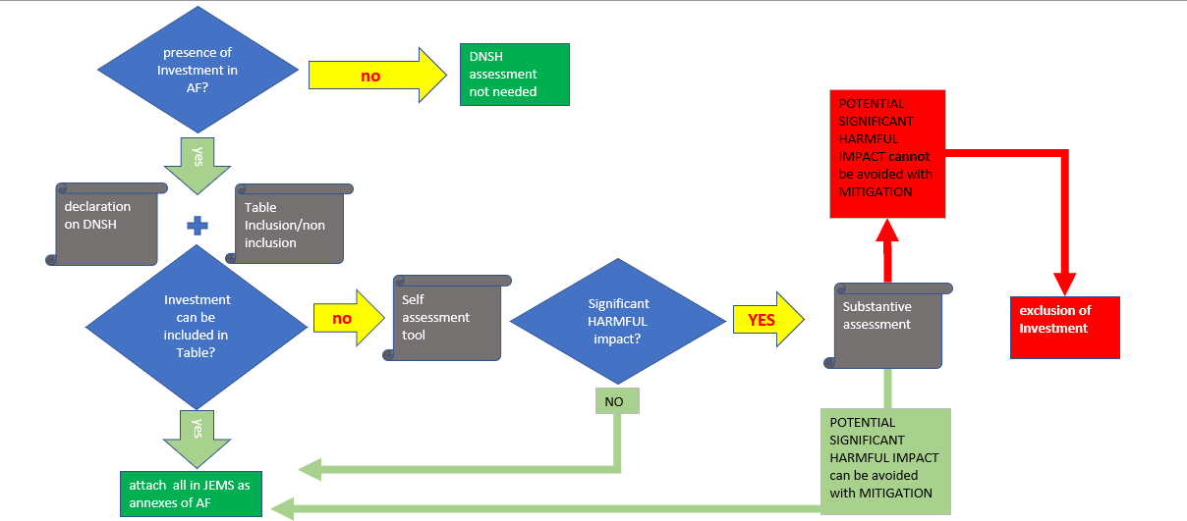

ANNEX 1 - LP/PP Declaration on DNSH

Title of the project proposal: [insert title ____________________________________________________]
Acronym of the project proposal: [insert acronym ____________________________________________]
I, the undersigned [name, surname ________________________________________________________]
born in [city, country____________] on [date of birth______] representative of [Name of the Project
partner in original language and name of the Project partner in English,
_______________________________________________________],
acting as partner N. [insert PP number__________________] of the above-mentioned project proposal:

by recalling what declared in PP declaration that “the organisation I represent will act according to EU Taxonomy criteria and the financed actions will not have harmful impact on the environment”;

SUBMIT
- Table of Inclusion/non-inclusion (Annex 2)

And (if applicable only):

- Self-assessment tool (Annex 3)
- Substantive assessment

COMMIT

To inform the Managing Authority and the Joint Secretariat of the Italy-Croatia Programme if any conditions underlying this declaration will change.

Signature Place and date

Name of the Signatory Position of the Signatory

ANNEX 2 - Tables of inclusion/non-inclusion

INVESTMENT:……….. (title of investment according to Application Form)
SO 1.1 | Aggregated typology of actions (line of interventions)
Topic art. 17 Taxonomy | Synergies with other programmes | Actions for development, innovation, application and transfer of technologies, systems and tools, knowhow and good practices
Climate change mitigation
Climate change adaptation
Sustainable use and protection of water and marine resources
Transition to circular economy, including waste prevention and recycling
Pollution prevention and control to air, water or land
The protection and restoration of biodiversity and ecosystems

INVESTMENT:………………. (title of investment according to Application Form)
SO 1.2 | Aggregated typology of actions (line of interventions)
Topic art. 17 Taxonomy | Actions to formulate and/or implement strategies and/or initiatives at cross-border level | Actions for development, innovation, application and transfer of technologies,  systems and tools, know-how and good practices
Climate change mitigation
Climate change adaptation
Sustainable use and protection of water and marine resources
Transition to circular economy, including waste prevention and recycling
Pollution prevention and control to air, water or land
The protection and restoration of biodiversity and ecosystems

INVESTMENT:………………………………………………….. (title of investment according to Application Form)
SO 2.1 | Aggregated typology of actions (line of interventions)
Topic art. 17 Taxonomy | Awareness raising actions | Actions to formulate and/or implement strategies and/or initiatives at cross-border level | Actions for development, innovation, application and transfer of technologies, systems and tools, knowhow and good practices | Preparation and start-up of small-scale investments and material interventions
Climate change mitigation
Climate change adaptation
Sustainable use and protection of water and marine resources
Transition to circular economy, including waste prevention and recycling
Pollution prevention and control to air, water or land
The protection and restoration of biodiversity and ecosystems

INVESTMENT:………………………………………………….. (title of investment according to Application Form)
SO 2.2 | Aggregated typology of actions (line of interventions)
Topic art. 17 Taxonomy | Awareness raising actions | Actions to formulate and/or implement strategies and/or initiatives at cross-border level | Actions for development, innovation, application and transfer of technologies, systems and tools, knowhow and good practices | Preparation and start-up of small-scale investments and material interventions
Climate change mitigation
Climate change adaptation
Sustainable use and protection of water and marine resources
Transition to circular economy, including waste prevention and recycling
Pollution prevention and control to air, water or land
The protection and restoration of biodiversity and ecosystems

INVESTMENT:………………………………………………….. (title of investment according to Application Form)
SO 3.1 | Aggregated typology of actions (line of interventions)
Topic art. 17 Taxonomy | Awareness raising actions | Actions to formulate and/or implement strategies and/or initiatives at cross-border level | Actions for development, innovation, application and transfer of technologies, systems and tools, knowhow and good practices | Preparation and start-up of small-scale investments and material interventions
Climate change mitigation
Climate change adaptation
Sustainable use and protection of water and marine resources
Transition to circular economy, including waste prevention and recycling
Pollution prevention and control to air, water or land
The protection and restoration of biodiversity and ecosystems

INVESTMENT:………………………………………………….. (title of investment according to Application Form)
SO 4.1 | Aggregated typology of actions (line of interventions)
Topic art. 17 Taxonomy | Awareness raising actions | Actions to formulate and/or implement strategies and/or initiatives at cross border level | Actions for development, innovation, application and transfer of technologies, systems and tools, knowhow and good practices | Preparation and start-up of small-scale investments and material interventions
Climate change mitigation
Climate change adaptation
Sustainable use and protection of water and marine resources
Transition to circular economy, including waste prevention and recycling
Pollution prevention and control to air, water or land
The protection and restoration of biodiversity and ecosystems

ANNEX 3 – SELF-ASSESSMENT TOOL

INVESTMENT:………………………………………………….. (title of investment according to Application Form)
Topic art. 17 Taxonomy | Evaluation criteria: an investment activity shall be considered to significantly harm when it: | Yes (tick) | No (tick) | If ‘No’, please explain briefly.  If ‘Yes’, explain the significance, extent and duration of the adverse impact.
1. Climate change mitigation | leads to significant greenhouse gas emissions | ☐ | ☐
2. Climate change adaption | leads to an increased adverse impact of the current climate and the expected future climate, on the activity itself or on people, nature or assets | ☐ | ☐
3. The sustainable use and protection of water and marine resources | is detrimental: (i) to the good status or the good ecological potential of bodies of water, including surface water and groundwater; or (ii) to the good environmental status of marine waters | ☐ | ☐
4. The transition to a circular economy | (i) leads to significant inefficiencies in the use of materials or in the direct or indirect use of natural resources such as non-renewable energy sources, raw materials, water and land at one or more stages of the life cycle of products, including in terms of durability, reparability, upgradability, reusability or recyclability of products; (ii) leads to a significant increase in the generation, incineration or disposal of waste, with the exception of the incineration of non-recyclable hazardous waste; or (iii) the long-term disposal of waste may cause significant and long-term harm to the environment | ☐ | ☐
5. Pollution prevention and control | leads to a significant increase in the emissions of pollutants into air, water or land, as compared with the situation before the activity started | ☐ | ☐
6. The protection and restoration of biodiversity and ecosystems | is: (i) significantly detrimental to the good condition and resilience of ecosystems; or (ii) detrimental to the conservation status of habitats and species, including those of Union interest. | ☐ | ☐

Prepared on the basis of: Commission Delegated Regulation (EU) 2021/2139 of 4 June 2021 supplementing Regulation (EU) 2020/852 of the European Parliament and of the Council by establishing the technical screening criteria for determining the conditions under which an economic activity qualifies as contributing substantially to climate change mitigation or climate change adaptation and for determining whether that economic activity causes no significant harm to any of the other environmental objectives.
EGESIF_21-0025-00 27/09/2021
In this case the assessment will take place during CC phase.
The tables have been structured based on the document “Application of the do no significant harm principle under Cohesion Policy”. Moreover, the Annex I, part II of the Commission Notice (C/2021/1054), Technical Guidance on the application of “do not significant harm” under the Recovery and Resilience Facility Regulation 2021/C 58/01, has also been considered. The elements in the first column are consistent with Article 17 of the Taxonomy Regulation. The actions related to the column "explanation on the significance of interaction" in the tables below, refer to aggregated typologies of action.
https://www.italy-croatia.eu/documents/555109/576593/SEA_extract_for_beneficiaries.pdf/24a546b0-b94c-43da-861a-f5b93f3824e1?t=1694590043656

