Transform Your Blue Economy Innovation into a Market Opportunity
with the Support of the Interreg Italy–Croatia Programme!
SEAS – Sustainable Enterprises Advancing Blue Solutions
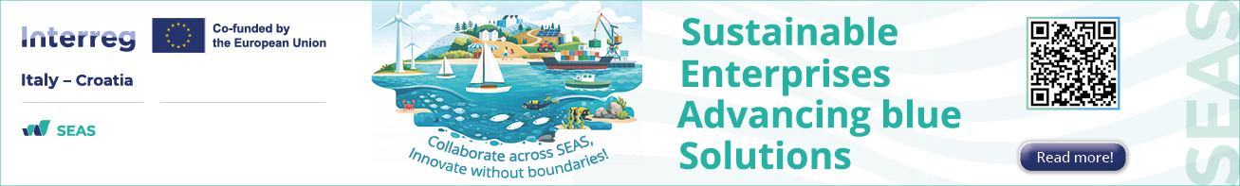
- Why SEAS?
The SEAS – Sustainable Enterprises Advancing Blue Solutions project will soon launch a call for proposals supporting micro, small and medium-sized enterprises (SMEs) from Croatia and Italy developing or commercialising innovative solutions in the blue economy through cross-border cooperation between companies on both sides of the Adriatic Sea.
- Key Information
Eligible applicants | Micro, small and medium-sized enterprises  registered and operating in the eligible cross-border area of Croatia and Italy
Partnership | A mandatory partnership between at least one Croatian and one Italian partner
EU contribution | Up to 80% of eligible project costs  in the form of a grant, in accordance with the General Block Exemption Regulation (GBER)
Total grant amount per project | 80.000,00 – 125.000,00 EUR
Project duration | 6 – 12 months
Total available funding | EUR 2.05 million  equally allocated between Croatian and Italian beneficiaries
Expected launch of the Call | October 2026.

- Eligible Activities
The Call will support projects that develop or bring to market innovative blue economy solutions (TRL 5 or higher) through mandatory cooperation between Croatian and Italian partners.
Project activities must fall within one of the following eligible blue economy sectors:
- Marine living resources: processing and distribution of fisheries and aquaculture products;
- Marine non-living resources: desalination;
- Marine renewable energy;
- Marine mineral resources;
- Blue biotechnology;
- Maritime infrastructure and robotics;
- Port activities: freight transport and storage, as well as port and water-related projects;
- Sustainable maritime transport;
- Coastal tourism.
- Eligible Costs
Eligible costs include project preparation, personnel, equipment, external expertise and services, and other costs in accordance with the Programme rules.
- How to Apply
Project proposals will be submitted through the SEAS platform. Detailed application requirements will be provided in the Guidelines for Applicants upon publication of the Call.
We encourage all interested applicants to register on the SEAS platform and begin searching for potential project partners.
For further information, please contact us at: seas@hamagbicro.hr

Don't Miss This Opportunity!
The SEAS project offers a unique opportunity for Croatian and Italian entrepreneurs to develop innovative blue economy solutions with the support of the European Union and establish new cross-border partnerships.
Start preparing your project today!

The SEAS – Sustainable Enterprises Advancing Blue Solutions project is co-financed by the European Union through the European Regional Development Fund under the Interreg Italy–Croatia Programme 2021–2027.

